Chapter 1: Introduction

1.1 Introduction
The rapid growth of distributed teams, online education, and remote collaboration has significantly increased the demand for applications that enable users to work together in real time regardless of geographical location. Digital whiteboard applications have emerged as an effective solution for brainstorming, planning, diagramming, teaching, and collaborative problem-solving by allowing multiple users to simultaneously interact with a shared workspace. However, many existing collaborative whiteboard solutions rely on centralized synchronization techniques that may introduce latency, create single points of failure, and become less efficient when handling concurrent modifications from multiple users.
The Collaborative Whiteboard System developed in this project addresses these challenges by providing a web-based platform that enables multiple users to collaboratively create, edit, and manage drawing boards in real time. The system incorporates modern web technologies and Conflict-free Replicated Data Types (CRDTs) using the Yjs framework to achieve efficient synchronization of shared whiteboard data while ensuring eventual consistency among all connected users.
The application supports a comprehensive set of collaborative features including real-time drawing, shape manipulation, live cursor presence, board sharing, role-based access control, integrated chat, comments on individual shapes, snapshot versioning, activity tracking, notifications, and asset management. These features allow users to collaborate effectively while maintaining controlled access and preserving the integrity of shared content.
To improve overall system performance, several optimized data structures and algorithms have been incorporated into the implementation. A custom Least Recently Used (LRU) Cache efficiently manages active Y.Doc instances in server memory, preventing excessive memory consumption. A Quadtree spatial indexing algorithm accelerates geometric operations such as shape selection and eraser collision detection by reducing the search space for spatial queries. Additionally, a Sliding Window Rate Limiter regulates socket events to prevent abuse while maintaining smooth real-time communication.
The system follows a modern three-tier architecture consisting of a Next.js frontend, an Express.js backend with Socket.IO for bidirectional communication, and a PostgreSQL database accessed through Prisma ORM for persistent data storage. Authentication is implemented using JSON Web Tokens (JWT), while role-based authorization ensures secure access to shared boards and collaborative features.
Overall, the proposed Collaborative Whiteboard System demonstrates how modern web technologies, real-time synchronization mechanisms, efficient data structures, and scalable software architecture can be integrated to provide a reliable and feature-rich collaborative environment suitable for educational, professional, and organizational use.

1.2 Problem Statement
Collaborative whiteboard applications have become increasingly important for facilitating remote communication and teamwork. Although numerous commercial and open-source solutions are available, many existing systems exhibit limitations that affect scalability, performance, and user experience when multiple users interact simultaneously.
One of the primary challenges in collaborative applications is maintaining consistency among concurrent updates. Traditional synchronization techniques, such as centralized locking or Operational Transformation (OT), may introduce synchronization delays, increase implementation complexity, or depend heavily on centralized coordination. These approaches can negatively impact the responsiveness of collaborative editing environments.
Performance also becomes a significant concern as the number of drawable objects increases. Conventional implementations often perform linear searches when selecting, erasing, or manipulating shapes, resulting in slower response times on complex whiteboards containing large numbers of graphical elements.
Another challenge involves server-side resource management. Collaborative editing frameworks maintain synchronization documents in memory throughout user sessions. Without an effective memory management strategy, inactive documents continue consuming server resources, reducing scalability as the number of active boards grows.
Furthermore, unrestricted real-time socket communication may expose the server to excessive client requests. High-frequency events such as cursor movements and drawing updates can overwhelm the server if appropriate rate-limiting mechanisms are not implemented.
This project addresses these challenges by implementing a CRDT-based collaborative synchronization model using Yjs, integrating a custom LRU Cache for efficient memory management, employing a Quadtree for optimized spatial indexing, and utilizing a Sliding Window Rate Limiter to regulate real-time communication. Together, these components improve the scalability, efficiency, and reliability of the collaborative whiteboard system.

1.3 Objectives

1.3.1 General Objective
To design and develop a web-based real-time Collaborative Whiteboard System that enables multiple users to collaborate efficiently through synchronized drawing, communication, and board management using modern web technologies.

1.3.2 Specific Objectives
- To develop a real-time collaborative whiteboard application supporting simultaneous multi-user editing.
- To implement CRDT-based synchronization using Yjs for maintaining consistency across distributed clients.
- To design and implement an LRU Cache for efficient management of server-side collaborative documents.
- To implement a Quadtree spatial indexing algorithm for efficient shape querying and collision detection.
- To implement a Sliding Window Rate Limiter to regulate socket communication and prevent excessive client requests.
- To implement secure user authentication using JSON Web Tokens (JWT).
- To provide role-based access control supporting Administrator, Editor, and Viewer roles.
- To implement board management features including board creation, sharing, invitations, and member management.
- To provide integrated collaboration features such as real-time chat, comments, notifications, activity logs, and snapshot versioning.
- To evaluate the correctness of the implemented algorithms through comprehensive unit testing.

1.4 Scope and Limitations

Scope
The developed Collaborative Whiteboard System includes the following functionalities:
- Web-based collaborative whiteboard accessible through modern web browsers.
- Real-time synchronization of drawing operations among multiple connected users.
- Support for drawing tools including freehand drawing, rectangle, circle, line, arrow, text, and image insertion.
- Shape editing, movement, deletion, and selection.
- Real-time cursor presence.
- Board sharing through invitations with role assignment.
- User authentication and authorization.
- Role-based permissions for board members.
- Integrated real-time messaging.
- Shape-specific commenting system.
- Board snapshot creation and restoration.
- Activity logging and notifications.
- Asset management for uploaded resources.
- Persistent storage using PostgreSQL and Prisma ORM.

Limitations
Despite its comprehensive functionality, the current implementation has several limitations:
- The application requires an active internet connection for real-time collaboration.
- The system currently targets desktop web browsers; native mobile applications are not included.
- Horizontal scaling for distributed server deployments has not been implemented.
- Offline collaborative editing is not supported.
- Advanced whiteboard templates and presentation features are outside the scope of this project.
- Performance evaluation under extremely large-scale concurrent usage is [To be Added Later].

1.5 Development Methodology
The Collaborative Whiteboard System was developed using the Agile Software Development Methodology, allowing incremental feature development through iterative development cycles. Agile was selected because the project required continuous refinement of features such as real-time synchronization, collaborative communication, user management, and custom algorithm integration.
The development process consisted of the following major phases:
- Requirement Analysis
  - Identification of functional and non-functional requirements.
  - Technology selection.
  - Architectural planning.
- System Design
  - Software architecture design.
  - Database design.
  - User interface planning.
  - UML modelling.
- Implementation
  - Backend API development.
  - Frontend development.
  - Database implementation.
  - Real-time communication.
  - Authentication and authorization.
  - Custom algorithm implementation.
- Testing
  - Unit testing of custom algorithms.
  - Functional testing.
  - Integration testing.
  - System validation.
- Documentation
  - Preparation of the final project report.
  - Compilation of diagrams, implementation details, testing results, and references.
Figure 1.1: Agile Development Lifecycle
(Development methodology diagram to be inserted later.)

1.6 Organization of the Report
This report is organized into six chapters, each describing a different aspect of the Collaborative Whiteboard System.
- Chapter 1 introduces the project by discussing the background, problem statement, objectives, scope, limitations, development methodology, and overall organization of the report.
- Chapter 2 presents the background study and literature review, including the theoretical concepts, technologies, and previous work related to collaborative whiteboard systems.
- Chapter 3 discusses the system analysis, including requirement analysis, feasibility analysis, database analysis, and object-oriented analysis supported by UML diagrams.
- Chapter 4 describes the system design, architectural design, database design, algorithm design, and other implementation-oriented design decisions.
- Chapter 5 explains the implementation details, development tools, testing methodology, unit testing results, and overall system evaluation.
- Chapter 6 summarizes the achievements of the project, presents the conclusions drawn from the implementation, and provides recommendations for future enhancements.

Placeholders for Later Chapters
The following placeholders will be used and updated as you provide the corresponding PlantUML diagrams and other artifacts:
- Figure 3.1: Use Case Diagram
- Figure 3.2: Entity-Relationship Diagram
- Figure 3.3: Class Diagram
- Figure 3.4: Object Diagram
- Figure 3.5: Sequence Diagram – Board Synchronization
- Figure 3.6: Sequence Diagram – Shape Creation
- Figure 3.7: Activity Diagram
- Figure 4.1: System Architecture
- Figure 4.2: Component Diagram
- Figure 4.3: Deployment Diagram
- Figure 4.4: Refined Class Diagram
- Figure 4.5: Refined Sequence Diagram
- Figure 4.6: Database Schema

CHAPTER 2

BACKGROUND STUDY AND LITERATURE REVIEW

2.1 Introduction
The rapid advancement of internet technologies and cloud computing has transformed the way individuals communicate, learn, and collaborate. Organizations, educational institutions, and distributed development teams increasingly rely on digital collaboration platforms that allow participants to work together regardless of their geographical locations. Among these collaborative platforms, digital whiteboards have become an essential tool for brainstorming, online teaching, project planning, software design, and visual communication.
Unlike traditional drawing applications that operate on a single device, collaborative whiteboard systems enable multiple users to simultaneously create, edit, and organize graphical content within a shared workspace. Modern collaborative systems require efficient synchronization mechanisms capable of handling concurrent edits while maintaining data consistency across all connected clients. Additionally, such systems must provide secure authentication, role-based authorization, persistent storage, efficient resource management, and optimized rendering to ensure a responsive user experience.
The Collaborative Whiteboard System developed in this project integrates several contemporary technologies, including CRDT-based synchronization using Yjs, WebSocket communication through Socket.IO, PostgreSQL for persistent data storage, Prisma ORM for database management, and Next.js for frontend development. Furthermore, specialized algorithms such as Quadtree spatial indexing and Least Recently Used (LRU) caching have been incorporated to improve system performance and scalability.
This chapter discusses the theoretical concepts, technologies, and existing systems that form the foundation of the proposed collaborative whiteboard application.

2.2 Background Study

2.2.1 Collaborative Whiteboard Systems
A collaborative whiteboard system is a software application that enables multiple users to interact with a common digital canvas in real time. Unlike conventional graphics editors, collaborative whiteboards continuously synchronize user actions so that every participant observes the same workspace regardless of their physical location.
Such systems have become increasingly important in remote education, distributed software development, engineering design, business meetings, and collaborative brainstorming sessions. Typical functionalities include freehand drawing, geometric shape creation, annotation, text editing, image insertion, commenting, and real-time communication.
The effectiveness of collaborative whiteboard systems depends largely on their ability to maintain synchronization among concurrent users while minimizing communication latency and preventing data conflicts.

2.2.2 Real-Time Collaboration
Real-time collaboration refers to the capability of multiple users to simultaneously modify shared data while observing changes almost instantly. In collaborative applications, maintaining synchronization among distributed clients presents several technical challenges, including network latency, concurrent editing conflicts, message ordering, and fault tolerance.
Traditional collaborative systems often rely on centralized synchronization methods that process every modification through a central server before distributing updates to connected clients. While this approach simplifies consistency management, it may become inefficient as the number of users and concurrent editing operations increases.
Modern collaborative systems therefore employ specialized synchronization techniques capable of resolving concurrent modifications while preserving a consistent shared state.

2.2.3 Conflict-free Replicated Data Types (CRDT)
Conflict-free Replicated Data Types (CRDTs) are distributed data structures designed to enable concurrent modifications without requiring centralized conflict resolution. Each participant maintains a local copy of the shared data structure, allowing edits to be performed immediately while synchronization occurs asynchronously in the background.
The Collaborative Whiteboard System utilizes the Yjs CRDT framework to synchronize whiteboard contents among multiple connected users. Every drawing operation is propagated as an incremental update and merged automatically across all connected clients. Since CRDTs are mathematically designed to converge toward a consistent state regardless of message ordering, they eliminate many synchronization issues commonly encountered in collaborative applications.
Compared with traditional synchronization approaches, CRDTs provide improved responsiveness, simplified conflict handling, and enhanced scalability for real-time collaborative environments.

2.2.4 WebSocket Communication
Conventional HTTP communication follows a request-response model that is unsuitable for highly interactive collaborative applications where updates occur continuously. Real-time systems instead require persistent bidirectional communication channels that enable both the client and server to exchange information immediately.
The Collaborative Whiteboard System utilizes Socket.IO, which builds upon the WebSocket protocol while providing automatic reconnection, event-based communication, transport fallbacks, and cross-platform compatibility. Socket.IO enables instant synchronization of drawing events, cursor positions, chat messages, notifications, and board updates among all connected users.
The event-driven communication model significantly reduces latency and improves the overall responsiveness of the application.

2.2.5 Next.js Framework
Next.js is a modern React-based framework designed for building scalable web applications. It provides routing, server-side rendering, static generation, API routes, middleware support, and optimized asset loading within a unified development environment.
The frontend of the Collaborative Whiteboard System is implemented using Next.js because it offers modular development, efficient rendering, optimized performance, and seamless integration with React libraries. The framework also simplifies project organization by providing a well-structured application architecture suitable for large-scale web applications.

2.2.6 Express.js
Express.js is a lightweight backend framework built on Node.js that simplifies the development of RESTful APIs and server-side applications. It provides middleware support, routing, request handling, authentication integration, and flexible application architecture.
Within the Collaborative Whiteboard System, Express.js manages authentication, authorization, board management, database communication, asset handling, snapshot management, notification services, and real-time Socket.IO integration.
Its modular architecture allows backend services to remain organized and maintainable as the application evolves.

2.2.7 PostgreSQL and Prisma ORM
Persistent storage plays a critical role in collaborative applications by preserving user accounts, board information, snapshots, messages, comments, assets, and activity logs.
The proposed system uses PostgreSQL as its relational database management system due to its reliability, transactional consistency, indexing capabilities, and support for complex relationships.
To simplify database development, Prisma ORM is employed as the data access layer. Prisma provides strongly typed database queries, schema migration tools, relationship management, and automatic client generation, reducing development complexity while maintaining database integrity.
The implemented database consists of interconnected entities including Users, Boards, Board Members, Shapes, Snapshots, Messages, Comments, Assets, Notifications, Audit Logs, and Board Settings.

2.2.8 Spatial Indexing using Quadtree
As collaborative whiteboards grow larger, searching every graphical object during selection or erasing operations becomes computationally expensive. Performing linear searches for every pointer movement significantly affects rendering performance.
To address this problem, the proposed system implements a Quadtree, a hierarchical spatial indexing data structure that recursively divides the drawing canvas into smaller rectangular regions. Each region stores only the objects located within its boundaries, allowing search operations to ignore unrelated portions of the canvas.
The implemented Quadtree accelerates marquee selection and eraser collision detection, significantly reducing the number of shape comparisons required during interactive editing.

2.2.9 LRU Cache
Collaborative editing frameworks maintain synchronization documents in server memory while users are actively editing shared boards. Retaining every document indefinitely would eventually exhaust available server memory.
The system therefore implements a custom Least Recently Used (LRU) Cache to manage active Y.Doc instances. The cache automatically removes the least recently accessed documents whenever the configured capacity is exceeded.
This memory management strategy improves scalability while ensuring that inactive collaborative sessions do not consume unnecessary server resources.

2.2.10 Rate Limiting
Real-time collaborative systems exchange large numbers of socket events each second. Without appropriate safeguards, malicious users or unintended excessive event generation may overload the server.
The Collaborative Whiteboard System implements a Sliding Window Rate Limiter that monitors socket events over configurable time intervals. Each event type is assigned a maximum request threshold, allowing legitimate collaborative activity while preventing abuse.
This mechanism enhances server stability and protects the application from excessive network traffic.

2.3 Literature Review
Several collaborative whiteboard platforms have demonstrated the effectiveness of real-time visual collaboration in educational, organizational, and software development environments. These systems provide valuable insights into interface design, collaboration techniques, synchronization methods, and user experience.

Miro
Miro is one of the most widely adopted online collaborative whiteboard platforms, providing real-time collaboration for distributed teams. It offers features including sticky notes, diagrams, templates, project planning tools, commenting, and collaborative brainstorming.
Although Miro provides an extensive feature set, many advanced functionalities require commercial subscriptions. Additionally, the underlying synchronization mechanisms are proprietary, limiting opportunities for academic experimentation and algorithmic customization.

Excalidraw
Excalidraw is an open-source collaborative drawing application that emphasizes simplicity and ease of use. It supports freehand drawing, diagrams, and real-time collaboration while maintaining a lightweight interface.
The project demonstrates effective integration of modern web technologies for collaborative editing and serves as an important reference for user interface design and drawing interactions.

Figma
Figma introduced highly responsive browser-based collaborative editing for interface design. Its real-time synchronization, multiplayer editing capabilities, version management, and collaborative commenting have significantly influenced modern collaborative software development.
Although Figma primarily targets interface design rather than general-purpose whiteboarding, its collaborative architecture demonstrates the effectiveness of low-latency synchronization and cloud-based collaboration.

Comparative Analysis
Table 2.1: Comparison of Existing Collaborative Whiteboard Systems
Feature | Miro | Excalidraw | Figma | Proposed System
Real-time Collaboration | ✓ | ✓ | ✓ | ✓
CRDT Synchronization | Partial | ✓ | Proprietary | ✓ (Yjs)
Role-based Access Control | ✓ | Limited | ✓ | ✓
Integrated Chat | ✓ | ✗ | Limited | ✓
Shape-specific Comments | ✓ | ✗ | ✓ | ✓
Snapshot Versioning | ✓ | Limited | ✓ | ✓
Spatial Indexing | Proprietary | Basic | Proprietary | ✓ (Quadtree)
Server-side Memory Optimization | Proprietary | ✗ | Proprietary | ✓ (LRU Cache)
Open-source Customization | ✗ | ✓ | ✗ | ✓

2.4 Chapter Summary
This chapter presented the theoretical background and technological foundations of the proposed Collaborative Whiteboard System. Key concepts including real-time collaboration, CRDT-based synchronization, WebSocket communication, modern web application frameworks, relational database management, spatial indexing, memory optimization, and rate limiting were discussed to establish the conceptual basis of the project.
Additionally, a review of existing collaborative platforms highlighted their strengths and limitations, providing context for the design decisions adopted in the proposed system. The next chapter builds upon these concepts by presenting the system analysis, including functional and non-functional requirements, feasibility analysis, and object-oriented analysis supported by UML models.

CHAPTER 3

SYSTEM ANALYSIS

3.1 Introduction
System analysis is a fundamental phase of software engineering that focuses on understanding the requirements, constraints, and expected functionality of a software system before its implementation. It provides a structured approach for identifying user needs, defining system behavior, evaluating technical feasibility, and establishing the foundation for system design.
For the Collaborative Whiteboard System, the system analysis phase involved identifying the functional and non-functional requirements of a real-time collaborative platform, analyzing user interactions, designing data flow, defining system components, and evaluating the technologies required to achieve reliable and scalable collaboration.
This chapter presents the requirement analysis, feasibility analysis, object-oriented analysis, and database analysis of the proposed system. It also includes placeholders for the UML diagrams that model the behavior and structure of the application.

3.2 Requirement Analysis
Requirement analysis defines the services that the proposed system must provide as well as the constraints under which it must operate. The identified requirements guided the design and implementation of the Collaborative Whiteboard System.
The requirements are classified into functional requirements and non-functional requirements.

3.3 Functional Requirements
The functional requirements describe the operations and services that the Collaborative Whiteboard System provides to its users.

User Management
The system shall:
- allow users to register accounts.
- authenticate users using secure login credentials.
- manage user sessions using JSON Web Tokens (JWT).
- allow authenticated users to update their profile information.
- maintain user information within the PostgreSQL database.

Board Management
The system shall:
- allow authenticated users to create collaborative whiteboards.
- allow users to rename boards.
- maintain ownership information for each board.
- allow users to delete boards.
- maintain board thumbnails.
- maintain board settings.

Collaboration
The system shall:
- synchronize drawing operations in real time.
- support multiple users editing the same board simultaneously.
- synchronize updates using CRDT-based replication through Yjs.
- broadcast drawing updates through Socket.IO.
- maintain eventual consistency among connected clients.

Drawing Tools
The system shall support:
- Freehand drawing
- Rectangle
- Circle
- Line
- Arrow
- Text
- Image insertion
The system shall also allow users to:
- move shapes,
- resize shapes,
- delete shapes,
- erase drawings,
- select multiple objects,
- perform marquee selection.

Board Sharing
The system shall:
- invite users to collaborate.
- assign member roles.
- support Administrator, Editor, and Viewer permissions.
- maintain board membership records.
- manage starred boards.

Communication
The system shall provide:
- real-time chat,
- shape-specific comments,
- user notifications,
- activity logs.

Snapshot Management
The system shall:
- create board snapshots.
- maintain snapshot versions.
- restore previous versions.
- preserve board history.

Asset Management
The system shall:
- upload assets.
- associate uploaded assets with boards.
- support image and file storage.
- maintain asset metadata.

Administrative Functions
The system shall:
- maintain audit logs.
- record user activities.
- monitor board events.
- manage notifications.

3.4 Non-Functional Requirements
The Collaborative Whiteboard System satisfies the following non-functional requirements.

Performance
The system should:
- synchronize updates with minimal latency.
- efficiently process concurrent editing operations.
- optimize spatial searches using Quadtree indexing.
- minimize server memory consumption using an LRU cache.

Reliability
The system should:
- maintain data consistency during concurrent editing.
- recover from temporary network interruptions.
- preserve persistent board information.

Scalability
The system should:
- support increasing numbers of collaborative boards.
- efficiently manage server memory.
- maintain acceptable response times as board complexity increases.

Security
The system should provide:
- JWT authentication.
- role-based authorization.
- password-protected boards.
- secure API communication.
- protected database access.

Maintainability
The system should:
- follow modular software architecture.
- separate frontend and backend services.
- organize database access through Prisma ORM.
- support future feature extensions.

Availability
The application should remain accessible whenever the backend server and database services are operational.

3.5 Feasibility Analysis
Before implementation, the proposed system was evaluated from technical, operational, economic, and schedule perspectives.

3.5.1 Technical Feasibility
The project is technically feasible because it utilizes mature and widely adopted technologies including:
- Next.js
- React
- Express.js
- Socket.IO
- Yjs
- PostgreSQL
- Prisma ORM
- TypeScript
These technologies provide the required support for real-time communication, distributed synchronization, secure authentication, database management, and scalable web application development.

3.5.2 Operational Feasibility
The system provides an intuitive browser-based interface requiring only internet access and a modern web browser.
The application's collaborative features closely resemble existing digital whiteboard platforms, minimizing the learning curve for new users.

3.5.3 Economic Feasibility
The project utilizes open-source technologies throughout its implementation.
No commercial software licenses are required for:
- PostgreSQL
- Node.js
- Express
- Prisma
- Next.js
- Socket.IO
- Yjs
Consequently, development costs remain minimal while providing enterprise-grade functionality.

3.5.4 Schedule Feasibility
The project was developed using an Agile methodology, allowing features to be implemented incrementally over multiple development iterations. This approach enabled continuous testing, feedback incorporation, and progressive refinement throughout the development lifecycle.

3.6 Object-Oriented Analysis
The Collaborative Whiteboard System follows an object-oriented architecture in which system functionality is organized into interacting entities representing users, collaborative boards, graphical objects, communication services, and persistent storage.
The primary actors interacting with the system include:
- Administrator
- Registered User
- Board Member
- Guest (where applicable)
The major system objects include:
- User
- Board
- Shape
- Snapshot
- Comment
- Message
- Notification
- Asset
- AuditLog
- BoardSettings
The interactions among these objects are represented through UML diagrams.

3.6.1 Use Case Diagram

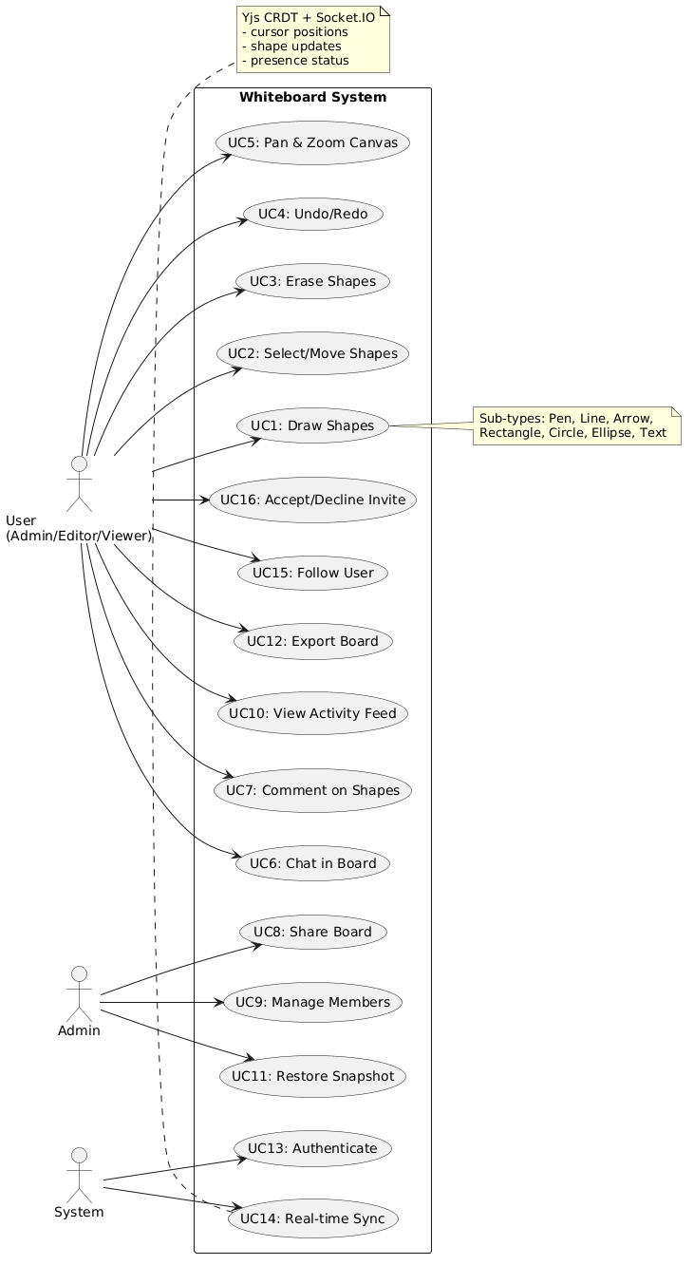
Figure 3.1: Use Case Diagram

3.6.2 Activity Diagram

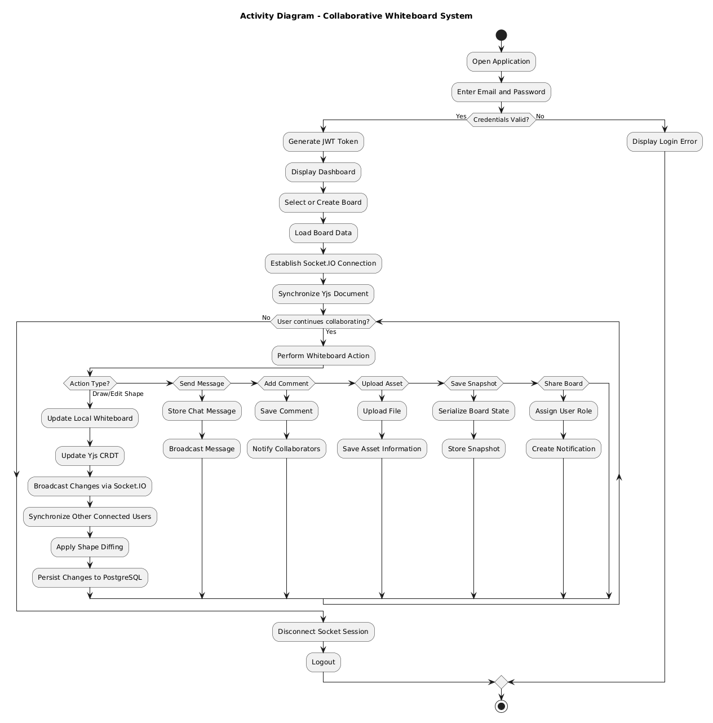
Figure 3.2: Activity Diagram

3.6.3 Sequence Diagram

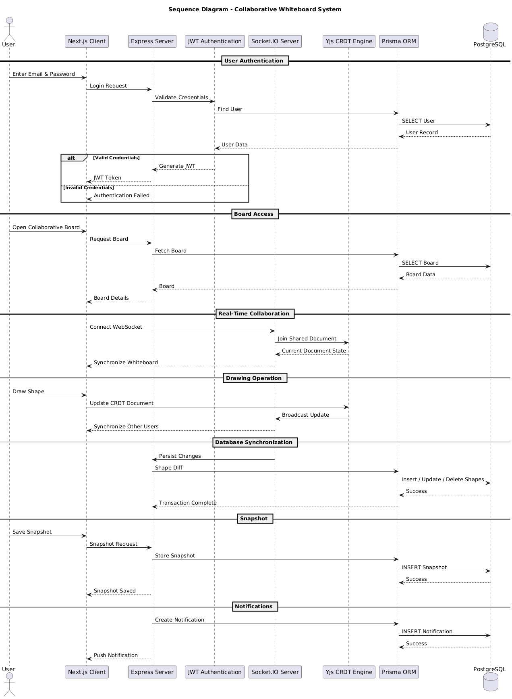
Figure 3.3: Sequence Diagram

3.6.4 Class Diagram

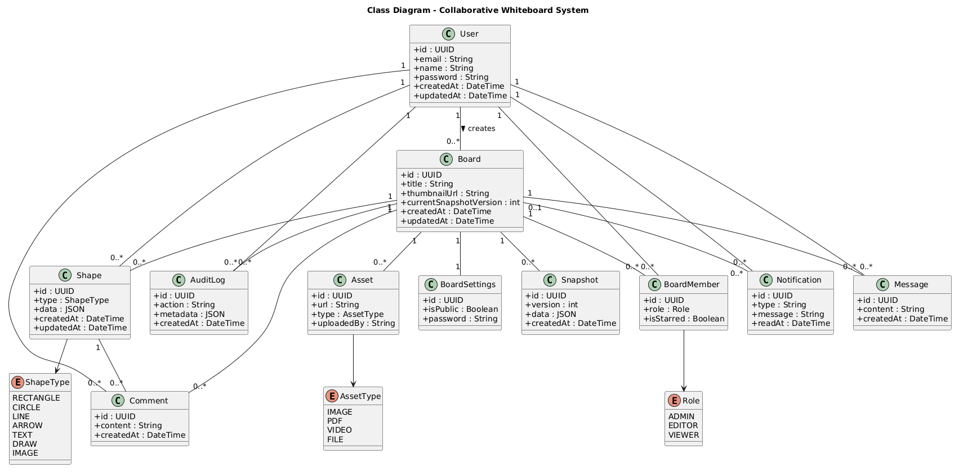
Figure 3.4: Class Diagram

3.6.5 Object Diagram

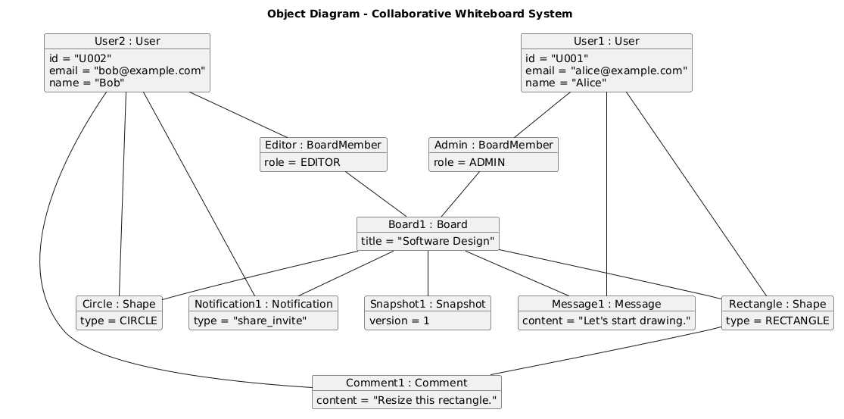
Figure 3.5: Object Diagram

3.7 Database Analysis
The Collaborative Whiteboard System employs a relational database implemented using PostgreSQL and managed through Prisma ORM. The database is designed to support collaborative editing, user management, communication, board versioning, notifications, and asset management while maintaining referential integrity through foreign key relationships.
The implemented schema consists of eleven primary entities, each representing a specific functional component of the application.

3.7.1 User
The User entity stores user account information, authentication credentials, and references to collaborative resources owned or accessed by each user. It maintains relationships with boards, shapes, messages, comments, notifications, and audit logs.

3.7.2 Board
The Board entity represents the primary collaborative workspace. It stores board metadata, ownership information, snapshots, assets, comments, messages, settings, and collaborative members.

3.7.3 BoardMember
The BoardMember entity manages many-to-many relationships between users and boards while maintaining role-based permissions.
Each membership record stores:
- Administrator
- Editor
- Viewer
permissions together with board-specific membership information.

3.7.4 Shape
The Shape entity stores graphical objects drawn on collaborative boards.
Each record contains:
- shape type,
- associated board,
- creator,
- JSON drawing data,
- timestamps.
The JSON representation allows different drawable objects to share a common storage model.

3.7.5 Snapshot
Snapshots preserve historical versions of collaborative boards.
Each snapshot stores:
- version number,
- serialized board state,
- creation timestamp.
Snapshots enable undo/restore functionality and historical board recovery.

3.7.6 Message
Stores chat messages exchanged between collaborators within a board.

3.7.7 Comment
Stores comments attached to individual graphical shapes.
This allows collaborators to discuss specific objects without affecting the drawing itself.

3.7.8 Asset
Stores uploaded resources including:
- images,
- PDF documents,
- videos,
- files.

3.7.9 AuditLog
Records important system activities for monitoring and auditing purposes.
Typical logged activities include:
- board updates,
- sharing,
- administrative actions,
- collaborative events.

3.7.10 Notification
Stores notifications delivered to users regarding invitations, mentions, and collaborative events.

3.7.11 BoardSettings
Stores configurable board options including:
- visibility,
- password protection,
- access configuration.

3.8 Entity Relationship Diagram
The relationships among the database entities are illustrated using the Entity Relationship Diagram.
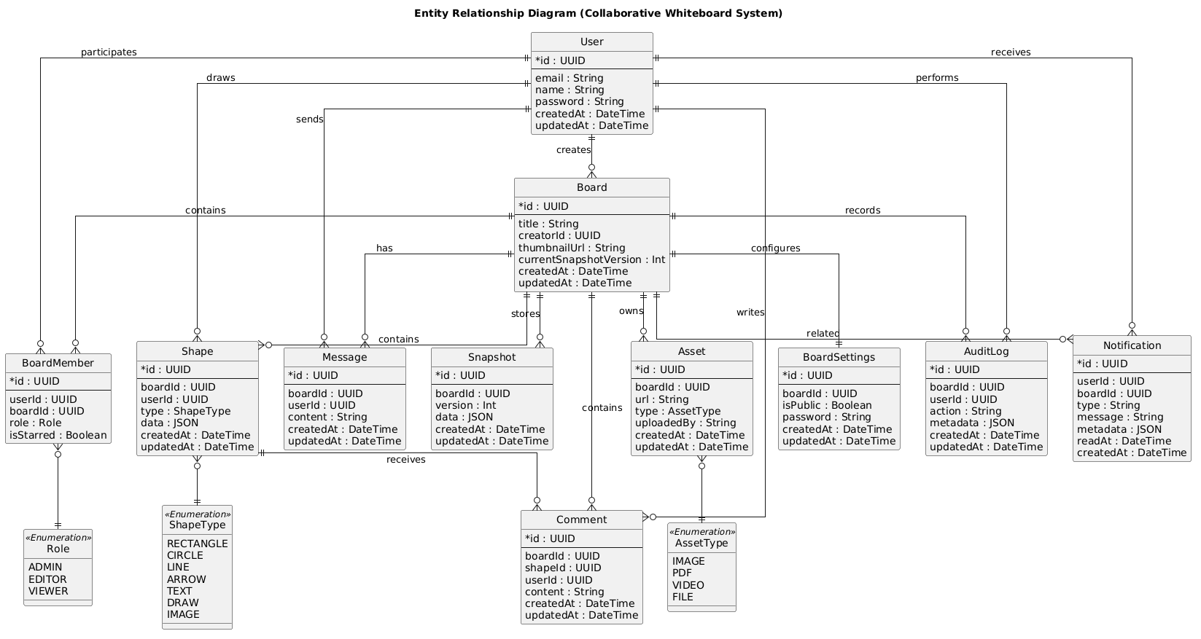
Figure 3.6: Entity Relationship Diagram

3.9 Chapter Summary
This chapter analyzed the proposed Collaborative Whiteboard System by identifying its functional and non-functional requirements, evaluating its technical, operational, economic, and schedule feasibility, and examining its object-oriented architecture. The analysis also described the relational database structure that supports collaborative editing, communication, version control, notifications, and user management.
The findings of this chapter establish the foundation for the next chapter, which presents the detailed system design. Chapter 4 will describe the overall software architecture, component interactions, deployment architecture, database design, and the custom algorithms—including the Quadtree, LRU Cache, Sliding Window Rate Limiter, and Shape Diffing mechanism—that enhance the performance and scalability of the Collaborative Whiteboard System.

CHAPTER 4

SYSTEM DESIGN

4.1 Introduction
System design is the process of transforming the requirements identified during the analysis phase into a comprehensive technical blueprint for software implementation. It specifies the architecture, components, data organization, communication mechanisms, algorithms, and deployment strategy that collectively enable the system to satisfy both functional and non-functional requirements.
The Collaborative Whiteboard System has been designed using a modular three-tier architecture consisting of a presentation layer, an application layer, and a data layer. The design emphasizes scalability, maintainability, performance, and reliability by separating responsibilities among independent system components.
The system integrates modern web technologies including Next.js, Express.js, Socket.IO, Yjs, PostgreSQL, and Prisma ORM. Additionally, specialized algorithms such as Quadtree spatial indexing, Least Recently Used (LRU) caching, Sliding Window Rate Limiting, and Shape Diffing have been incorporated to improve performance and resource utilization.
This chapter presents the architectural design, component design, deployment architecture, database design, and detailed descriptions of the custom algorithms implemented within the system.

4.2 System Architecture
The Collaborative Whiteboard System follows a three-tier client-server architecture in which the presentation, application, and data management layers operate independently while communicating through well-defined interfaces.
The architecture is composed of the following layers:

Presentation Layer
The presentation layer is implemented using Next.js with React and TypeScript. It provides users with an interactive graphical interface for creating, editing, and collaborating on whiteboards. This layer is responsible for rendering graphical objects, capturing user interactions, communicating with the backend services, and synchronizing collaborative updates.
Major responsibilities include:
- User authentication interfaces
- Whiteboard rendering
- Drawing tools
- Shape manipulation
- Chat interface
- Comment system
- Board management
- Real-time cursor visualization
- Notification display

Application Layer
The application layer is implemented using Express.js running on Node.js.
This layer performs:
- Authentication
- Authorization
- Business logic
- Socket.IO event handling
- CRDT synchronization
- Snapshot management
- Board sharing
- Notification services
- Audit logging
- Database interaction through Prisma ORM
The application server acts as the central coordination point for collaborative editing while maintaining consistency among all connected clients.

Data Layer
The data layer utilizes PostgreSQL for persistent storage.
Prisma ORM provides an abstraction layer that simplifies database communication while ensuring type safety and efficient query execution.
Persistent information includes:
- User accounts
- Boards
- Board members
- Shapes
- Snapshots
- Assets
- Messages
- Comments
- Notifications
- Audit logs
- Board settings

Figure 4.1: Overall System Architecture
(System architecture diagram to be inserted later.)

4.3 Component Design
The application is organized into multiple independent components, each responsible for a specific aspect of system functionality.

4.3.1 Authentication Component
Responsible for:
- User registration
- Login
- JWT generation
- Session validation
- Authorization middleware

4.3.2 Board Management Component
Provides functionality for:
- Creating boards
- Renaming boards
- Deleting boards
- Sharing boards
- Managing collaborators
- Starring boards
- Configuring board settings

4.3.3 Drawing Engine
The drawing engine is responsible for rendering graphical objects and processing user drawing operations.
Supported drawing objects include:
- Rectangle
- Circle
- Line
- Arrow
- Text
- Freehand drawing
- Image
Each graphical object is represented as a Shape entity whose geometric information is stored as JSON data within the PostgreSQL database.

4.3.4 Real-Time Synchronization Component
This component maintains synchronization among all users collaborating on the same whiteboard.
Synchronization is implemented using:
- Socket.IO
- Yjs CRDT
Each connected client maintains a synchronized copy of the collaborative document.
Whenever modifications occur:
- Local state is updated.
- CRDT updates are generated.
- Updates are transmitted to the server.
- The server distributes updates to connected users.
- Every client converges toward the same shared state.
This approach enables simultaneous editing without manual conflict resolution.

4.3.5 Communication Component
Supports collaborative communication through:
- Board chat
- Shape comments
- Notifications
- Audit logs
These features improve coordination among collaborators while maintaining a record of important activities.

4.3.6 Snapshot Component
The snapshot module periodically stores serialized board states.
Each snapshot contains:
- Board identifier
- Snapshot version
- Serialized board data
- Timestamp
Snapshots enable:
- Undo
- Restore
- Historical version tracking

4.3.7 Asset Management Component
Responsible for managing uploaded files including:
- Images
- PDF documents
- Videos
- Other supported files
Each uploaded asset is linked to its corresponding collaborative board.

Figure 4.2: Component Diagram
(PlantUML diagram to be inserted later.)

4.4 Deployment Design
The application is deployed using multiple cooperating services.
The deployment environment consists of:

Client Browser
- Executes the Next.js frontend.
- Renders the collaborative whiteboard.
- Maintains WebSocket connections.

Application Server
Runs:
- Express.js
- Socket.IO
- Authentication services
- Business logic
- Yjs synchronization engine

PostgreSQL Database
Stores all persistent application data including:
- users
- boards
- shapes
- comments
- snapshots
- notifications
- assets
- audit logs

Cloud Storage (Optional)
Supports external storage for uploaded assets such as images and documents.

Figure 4.3: Deployment Diagram
(PlantUML diagram to be inserted later.)

4.5 Database Design
The database has been designed using a relational model implemented through PostgreSQL and Prisma ORM.
The schema consists of eleven interconnected entities supporting collaborative editing, communication, access control, and version management.
Important design considerations include:
- UUID-based primary keys
- Foreign key relationships
- Cascade deletion
- JSON storage for flexible graphical data
- Snapshot versioning
- Timestamp tracking
- Role-based permissions

Core Entities
The principal entities include:
- User
- Board
- BoardMember
- Shape
- Snapshot
- Message
- Comment
- Asset
- Notification
- AuditLog
- BoardSettings

Relationship Summary
Key relationships include:
- One user can create multiple boards.
- A board can have multiple collaborators.
- A user may collaborate on multiple boards.
- A board contains multiple shapes.
- Each shape may contain multiple comments.
- Boards maintain multiple snapshots.
- Notifications may optionally reference boards.
- Board settings maintain a one-to-one relationship with each board.

Figure 4.4: Database Schema
(Generated from the Prisma schema / PlantUML to be inserted later.)

4.6 Algorithm Design
Several custom algorithms have been implemented to improve the performance, scalability, and reliability of the Collaborative Whiteboard System.

4.6.1 Least Recently Used (LRU) Cache

Purpose
The LRU Cache manages active Y.Doc instances on the server while preventing excessive memory consumption. Since each collaborative board requires an in-memory synchronization document, retaining inactive documents indefinitely would reduce scalability.
The implemented cache automatically removes the least recently accessed document whenever the configured capacity is exceeded.

Working Principle
The cache combines:
- a hash map for constant-time lookup,
- a doubly linked list for maintaining usage order.
Whenever a document is accessed, it is promoted to the head of the list. When the cache reaches capacity, the document at the tail is evicted, and the associated Y.Doc instance is destroyed to release memory.

Complexity Analysis
Operation | Time Complexity
Lookup | O(1)
Insert | O(1)
Update | O(1)
Deletion | O(1)
Eviction | O(1)

Algorithm 4.1: LRU Cache
(Pseudocode derived from the implementation to be inserted later.)

4.6.2 Quadtree Spatial Index

Purpose
Efficient selection and collision detection are essential for maintaining responsiveness in collaborative drawing applications. A naïve implementation that scans every graphical object during each interaction becomes increasingly inefficient as the number of shapes grows.
To address this challenge, the system employs a Quadtree, a hierarchical spatial indexing structure that recursively partitions the drawing canvas into smaller regions. Instead of examining every shape, spatial queries are limited to the relevant regions of the canvas, reducing unnecessary comparisons.

Working Principle
The implemented Quadtree stores shapes together with their Axis-Aligned Bounding Boxes (AABB).
When the number of shapes within a node exceeds the configured capacity, the node is automatically subdivided into four child quadrants. New shapes are inserted into the smallest quadrant capable of fully containing their bounding boxes. During spatial queries, only nodes whose regions intersect the query rectangle are traversed, while unrelated branches are ignored.
This implementation supports insertion, querying, clearing, rebuilding, and automatic subdivision. It is integrated into the whiteboard to accelerate marquee selection and eraser collision detection.

Complexity Analysis
Operation | Average Time | Worst Case
Insert | O(log n) | O(n)
Query | O(log n + k) | O(n)
Clear | O(1) | O(1)
Rebuild | O(n log n) | O(n²)
where n represents the number of stored shapes and k denotes the number of query results.

Algorithm 4.2: Quadtree Spatial Index
(Pseudocode derived from the implementation to be inserted later.)

4.6.3 Sliding Window Rate Limiter

Purpose
The Sliding Window Rate Limiter protects the server from excessive socket requests while preserving smooth real-time collaboration. High-frequency events such as cursor movement and drawing updates are monitored within configurable time windows to prevent abuse and maintain stable server performance.

Working Principle
Each socket event is associated with a configurable request limit over a fixed time interval. When a new event is received, outdated timestamps outside the current window are removed, and the number of remaining requests is evaluated. Requests exceeding the configured threshold are rejected, while valid requests are processed normally.
The limiter operates independently for each socket connection and event type, ensuring fair distribution of server resources among users.

Algorithm 4.3: Sliding Window Rate Limiter
(Pseudocode to be inserted later.)

4.6.4 Shape Diffing Algorithm

Purpose
The Shape Diffing Algorithm minimizes unnecessary database writes by synchronizing only those graphical objects that have been added, modified, or removed during a collaboration session. This optimization reduces write amplification and improves overall database performance.

Working Principle
The algorithm compares the current collection of shapes received from the client with the corresponding records stored in the database. It identifies deleted shapes, detects modified objects through JSON comparison, and inserts or updates only the affected records within a single database transaction, ensuring atomicity and consistency.

Algorithm 4.4: Shape Diffing
(Pseudocode to be inserted later.)

4.7 Design Diagrams
The detailed UML models illustrating the internal structure and dynamic behavior of the Collaborative Whiteboard System are presented below.
- Figure 4.5: Refined Class Diagram
(PlantUML diagram to be inserted later.)
- Figure 4.6: Sequence Diagram – Real-Time Board Synchronization
(PlantUML diagram to be inserted later.)
- Figure 4.7: Sequence Diagram – Undo and Snapshot Restoration
(PlantUML diagram to be inserted later.)
- Figure 4.8: Activity Diagram – Board Collaboration Workflow
(PlantUML diagram to be inserted later.)

4.8 Chapter Summary
This chapter presented the design of the Collaborative Whiteboard System by describing its layered architecture, modular components, deployment environment, and relational database structure. The chapter also explained the rationale behind the custom algorithms developed to improve performance, scalability, and reliability, including the LRU Cache, Quadtree spatial index, Sliding Window Rate Limiter, and Shape Diffing algorithm.
Together, these design decisions establish a robust foundation for the implementation of a real-time collaborative application capable of supporting concurrent editing, efficient synchronization, and optimized resource management. The next chapter details the implementation of these components and evaluates their correctness through unit testing, functional testing, and system validation.

CHAPTER 5

SYSTEM IMPLEMENTATION, TESTING AND EVALUATION

5.1 Introduction
This chapter describes the implementation of the Collaborative Whiteboard System and presents the testing procedures used to verify its correctness and reliability. The implementation phase transformed the architectural and design specifications presented in the previous chapters into a fully functional web-based application capable of supporting real-time collaborative editing.
The system was developed using modern web technologies and follows a modular implementation approach. Individual components, including user authentication, board management, real-time synchronization, communication services, database operations, and custom optimization algorithms, were implemented independently before being integrated into the complete application.
To ensure the correctness of critical algorithms, unit testing was performed using the Vitest testing framework. The implemented tests validate the behavior of the Quadtree spatial indexing algorithm and the Least Recently Used (LRU) Cache under a variety of operating conditions.

5.2 Development Environment
The Collaborative Whiteboard System was developed using the software tools listed in Table 5.1.
Table 5.1: Development Environment
Category | Technology
Programming Language | TypeScript
Frontend Framework | Next.js
UI Library | React
Backend Framework | Express.js
Runtime Environment | Node.js
Real-time Communication | Socket.IO
Collaborative Framework | Yjs
Database | PostgreSQL
ORM | Prisma
Authentication | JSON Web Token (JWT)
Unit Testing | Vitest
Version Control | Git
Package Manager | npm
Development Environment | Visual Studio Code

5.3 System Implementation
The implementation of the Collaborative Whiteboard System follows the modular architecture presented in Chapter 4. Each subsystem performs a distinct function while interacting with other modules through clearly defined interfaces.

5.3.1 User Authentication Module
The authentication module is responsible for verifying user identity and controlling access to protected resources.
Major implementation features include:
- User registration
- Secure login
- JWT generation
- Token validation
- Protected API routes
- Role-based authorization
Authenticated users receive a JSON Web Token that is attached to subsequent requests, allowing the server to validate permissions before processing operations.

5.3.2 Board Management Module
This module enables users to create and manage collaborative whiteboards.
Implemented functionality includes:
- Board creation
- Board deletion
- Board renaming
- Board sharing
- Member invitation
- Role assignment
- Board starring
- Board settings configuration
Board information is stored persistently in PostgreSQL using Prisma ORM.

5.3.3 Real-Time Collaboration Module
Real-time collaboration is implemented through the integration of Socket.IO and Yjs.
Whenever a participant modifies the shared whiteboard:
- The local client updates its CRDT document.
- The generated update is transmitted to the server.
- The server broadcasts the update to other connected users.
- Each client merges the received update automatically.
Because Yjs implements Conflict-free Replicated Data Types (CRDTs), concurrent edits converge toward a consistent shared state without requiring explicit conflict resolution.

5.3.4 Drawing Module
The drawing module provides users with interactive graphical editing capabilities.
Implemented drawing tools include:
- Freehand drawing
- Rectangle
- Circle
- Line
- Arrow
- Text
- Image insertion
Each graphical object is stored as a Shape entity containing JSON-encoded drawing information, enabling flexible support for multiple object types.

5.3.5 Communication Module
The communication subsystem supports collaboration through:
- Real-time chat
- Shape-specific comments
- User notifications
- Activity logs
These features facilitate communication among collaborators while preserving important project history.

5.3.6 Snapshot Module
The snapshot module periodically stores serialized versions of collaborative boards.
Each snapshot contains:
- Board identifier
- Snapshot version
- Serialized board state
- Timestamp
Snapshots enable users to restore previous versions of collaborative work when required.

5.3.7 Database Module
Persistent application data is managed through PostgreSQL using Prisma ORM.
The implemented database stores:
- Users
- Boards
- Board Members
- Shapes
- Snapshots
- Messages
- Comments
- Assets
- Notifications
- Audit Logs
- Board Settings
Prisma simplifies database operations through type-safe queries and automatic schema management.

5.4 Implementation of Performance Optimization Techniques
Several optimization techniques were incorporated into the implementation to improve performance and scalability.

5.4.1 Quadtree Spatial Index
The implemented Quadtree recursively partitions the drawing canvas into hierarchical regions.
Its implementation provides:
- Automatic subdivision
- Efficient insertion
- Spatial querying
- Tree rebuilding
- Collision detection
The Quadtree accelerates:
- Marquee selection
- Eraser collision detection
by reducing the number of graphical objects examined during each operation.

5.4.2 Least Recently Used Cache
The LRU Cache manages active collaborative documents maintained by the server.
Whenever cache capacity is exceeded:
- the least recently accessed document is removed,
- associated synchronization resources are released,
- memory becomes available for newly active collaborative sessions.
This strategy improves scalability by preventing inactive boards from occupying server memory indefinitely.

5.4.3 Sliding Window Rate Limiter
The Sliding Window Rate Limiter regulates socket communication.
Its implementation:
- monitors client request frequency,
- prevents excessive event generation,
- reduces the risk of denial-of-service style abuse,
- maintains responsive server performance.

5.4.4 Shape Diffing
The Shape Diffing implementation compares client-side board data with persistent database records.
Only shapes that have been:
- created,
- modified,
- deleted
are synchronized with the database.
This significantly reduces unnecessary write operations.

5.5 Testing
Testing was performed throughout development to verify the correctness of the implemented algorithms and ensure reliable system behavior.
The project primarily employed unit testing using the Vitest framework.

5.5.1 Quadtree Testing
Eight unit tests were developed to verify the correctness of the Quadtree implementation.
Table 5.2: Quadtree Unit Test Cases
Test Case | Purpose | Expected Result
Empty Query | Query an empty tree | Returns an empty collection
Single Shape Insertion | Insert one shape and query | Shape is correctly returned
Outside Query | Query outside stored region | No shapes returned
Multiple Shape Query | Insert multiple shapes | Only intersecting shapes returned
Clear Operation | Remove all shapes | Tree becomes empty
Rebuild Operation | Rebuild tree with new data | Previous shapes replaced
Boundary Intersection | Test edge intersection | Correct intersection detection
Automatic Subdivision | Insert beyond capacity | Tree subdivides automatically
All Quadtree unit tests executed successfully.

5.5.2 LRU Cache Testing
Ten unit tests were developed for the custom Least Recently Used Cache implementation.
Table 5.3: LRU Cache Unit Test Cases
Test Case | Purpose | Expected Result
Set/Get | Store and retrieve values | Correct value returned
Missing Key | Retrieve absent key | Undefined returned
Cache Eviction | Exceed cache capacity | Least recently used item removed
Promotion on Access | Access existing item | Item promoted to most recently used
Update Existing Entry | Update stored value | Value updated correctly
Delete Entry | Remove item | Entry deleted successfully
Contains Check | Verify existence | Correct boolean returned
Key Retrieval | Retrieve cache keys | All keys returned
Cache Size | Verify capacity | Size correctly maintained
Object Storage | Store objects | Objects retrieved correctly
All LRU Cache tests passed successfully.

5.6 Test Summary
The implemented unit tests demonstrate the correctness of the two principal custom optimization algorithms.
Table 5.4: Unit Testing Summary
Module | Number of Tests | Status
Quadtree | 8 | Passed
LRU Cache | 10 | Passed
Total | 18 | Passed
The successful execution of all unit tests indicates that the implemented optimization algorithms behave as expected under normal operating conditions.

5.7 System Evaluation
The implemented Collaborative Whiteboard System satisfies the functional requirements identified during the analysis phase.
Major implemented capabilities include:
- Secure user authentication
- Collaborative board management
- Real-time synchronization
- Interactive drawing
- Board sharing
- Role-based permissions
- Chat functionality
- Shape comments
- Snapshot versioning
- Notification system
- Asset management
- Activity logging
The incorporation of Quadtree spatial indexing, LRU caching, Sliding Window Rate Limiting, and Shape Diffing further improves the performance, scalability, and efficiency of the system.
Formal performance benchmarking and scalability measurements are [To be Added Later].

5.8 Screenshots
The following figures will present screenshots of the implemented application.
Figure 5.1: User Login Interface
(Screenshot to be inserted later.)
Figure 5.2: User Registration Interface
(Screenshot to be inserted later.)
Figure 5.3: Dashboard Interface
(Screenshot to be inserted later.)
Figure 5.4: Collaborative Whiteboard Workspace
(Screenshot to be inserted later.)
Figure 5.5: Board Sharing Dialog
(Screenshot to be inserted later.)
Figure 5.6: Real-Time Collaboration Interface
(Screenshot to be inserted later.)
Figure 5.7: Snapshot Management Interface
(Screenshot to be inserted later.)
Figure 5.8: Notification Panel
(Screenshot to be inserted later.)

5.9 Chapter Summary
This chapter described the implementation and evaluation of the Collaborative Whiteboard System. It outlined the technologies used during development, explained the implementation of the major system modules, and discussed the optimization techniques incorporated to enhance performance and scalability. The chapter also presented the unit testing process, where the custom Quadtree and LRU Cache implementations were verified through eighteen test cases, all of which passed successfully.
The next and final chapter summarizes the overall achievements of the project, presents the conclusions drawn from the implementation, discusses the limitations of the current system, and proposes recommendations for future enhancements.

CHAPTER 6

CONCLUSION AND FUTURE RECOMMENDATIONS

6.1 Introduction
This chapter presents the overall conclusion of the Collaborative Whiteboard System project. It summarizes the objectives achieved, evaluates the completed implementation against the initial project requirements, discusses the limitations of the current system, and outlines potential enhancements that may be incorporated in future versions. The chapter provides a comprehensive reflection on the development process and the contribution of the proposed system to real-time collaborative applications.

6.2 Project Summary
The primary objective of this project was to design and develop a web-based Collaborative Whiteboard System that enables multiple users to create, edit, and manage graphical content simultaneously within a shared workspace. The system was intended to facilitate efficient collaboration for educational, professional, and creative environments by combining interactive drawing capabilities with real-time synchronization.
To achieve this objective, the application was developed using a modern technology stack consisting of Next.js, React, Express.js, Socket.IO, Yjs, PostgreSQL, Prisma ORM, and TypeScript. The system incorporates secure user authentication, role-based authorization, collaborative board management, real-time drawing synchronization, integrated communication tools, snapshot versioning, asset management, notifications, and audit logging.
In addition to the core collaborative features, several performance optimization techniques were implemented to improve scalability and responsiveness. These include Quadtree spatial indexing for efficient shape selection and collision detection, an LRU Cache for optimized server-side memory management of collaborative documents, a Sliding Window Rate Limiter to regulate socket communication, and a Shape Diffing mechanism to minimize unnecessary database operations.
The modular architecture adopted throughout development promotes maintainability, extensibility, and separation of concerns, making the application suitable for future enhancement and continued development.

6.3 Achievement of Objectives
The objectives identified during the planning phase were successfully implemented through the completed system.
Table 6.1: Achievement of Project Objectives
Project Objective | Status
Develop a web-based collaborative whiteboard | Achieved
Implement real-time collaboration | Achieved
Support simultaneous multi-user editing | Achieved
Implement secure user authentication | Achieved
Provide role-based board sharing | Achieved
Develop graphical drawing tools | Achieved
Implement integrated chat and comments | Achieved
Support board snapshot versioning | Achieved
Implement notification and audit logging | Achieved
Optimize performance using Quadtree indexing | Achieved
Optimize memory usage using LRU Cache | Achieved
Implement unit testing for critical algorithms | Achieved
The completed system satisfies the functional requirements established during the system analysis phase and demonstrates the successful integration of modern collaborative technologies within a unified application.

6.4 Contributions of the Project
The Collaborative Whiteboard System makes several significant technical contributions through the integration of modern software engineering principles and optimization techniques.
The major contributions include:
- Development of a browser-based real-time collaborative whiteboard application.
- Integration of CRDT-based synchronization using Yjs to support concurrent editing without manual conflict resolution.
- Implementation of efficient real-time communication through Socket.IO.
- Design of a modular and scalable three-tier software architecture.
- Development of a relational database schema supporting collaborative workspaces, snapshots, notifications, and communication features.
- Implementation of Quadtree spatial indexing to improve graphical object selection and collision detection.
- Development of a custom Least Recently Used (LRU) Cache for efficient management of active collaborative documents.
- Implementation of a Sliding Window Rate Limiter to improve server stability and resource utilization.
- Integration of Shape Diffing techniques to reduce unnecessary database write operations.
- Validation of critical optimization algorithms through comprehensive unit testing.
Collectively, these contributions demonstrate the practical application of contemporary web technologies and distributed collaboration techniques in the development of scalable collaborative software.

6.5 Limitations of the System
Although the Collaborative Whiteboard System successfully fulfills its intended objectives, several limitations remain that provide opportunities for future improvement.
The current implementation has the following limitations:
- Performance evaluation under large-scale concurrent user loads has not yet been formally benchmarked.
- Offline collaboration and automatic synchronization after reconnection are not fully implemented.
- Integrated voice and video communication are not available within the application.
- Advanced whiteboard templates and diagram libraries are not currently supported.
- Mobile-specific interface optimization is limited.
- Advanced administrative analytics and reporting dashboards are not included.
- Automated backup scheduling and disaster recovery mechanisms have not been fully implemented.
- Integration with third-party productivity platforms is currently unavailable.
These limitations do not affect the core collaborative functionality but represent areas for future development.

6.6 Future Recommendations
Several enhancements may further improve the functionality, usability, and scalability of the Collaborative Whiteboard System.
Future development may include:
- Implementation of offline editing with automatic synchronization after network restoration.
- Integration of voice and video conferencing to enhance communication among collaborators.
- AI-assisted drawing recognition, diagram generation, and content suggestions.
- Support for additional drawing tools and advanced graphical editing features.
- Mobile-native applications for Android and iOS platforms.
- Integration with cloud storage providers for file management.
- Advanced analytics for monitoring user activity and board usage.
- End-to-end encryption for collaborative sessions requiring enhanced security.
- Automatic backup scheduling and disaster recovery mechanisms.
- Horizontal server scaling through distributed collaborative synchronization.
- Integration with external project management and productivity platforms.
- Performance optimization through distributed caching and load balancing.
These enhancements would further strengthen the system's suitability for large-scale enterprise and educational collaboration.

6.7 Final Conclusion
The Collaborative Whiteboard System demonstrates the successful implementation of a modern web-based collaborative platform capable of supporting real-time multi-user interaction within a shared digital workspace. By integrating contemporary technologies such as Next.js, Express.js, Socket.IO, Yjs, PostgreSQL, and Prisma ORM, the project provides a reliable foundation for collaborative drawing, communication, and shared content management.
The incorporation of specialized optimization techniques, including Quadtree spatial indexing, Least Recently Used (LRU) caching, Sliding Window Rate Limiting, and Shape Diffing, enhances the application's responsiveness, scalability, and resource efficiency. Furthermore, the modular architecture adopted throughout the project facilitates maintainability and future extensibility.
The successful completion of this project demonstrates the practical application of distributed collaboration technologies and modern software engineering practices in solving real-world collaborative challenges. With the recommended future enhancements, the proposed system has the potential to evolve into a comprehensive collaborative platform suitable for educational institutions, software development teams, business organizations, and other environments requiring efficient real-time visual collaboration.

References
[To be formatted according to your university's required citation style (e.g., APA 7th, IEEE, or Harvard).]
Suggested references based on the technologies used include:
- Next.js Documentation.
- React Documentation.
- Express.js Documentation.
- Node.js Documentation.
- Socket.IO Documentation.
- Yjs Documentation.
- Prisma ORM Documentation.
- PostgreSQL Documentation.
- TypeScript Documentation.
- JSON Web Token (JWT) Documentation.
- Vitest Documentation.
- Software Engineering textbooks and research papers on collaborative systems and CRDTs.

Appendices

Appendix A: Source Code
[To be Added Later]

Appendix B: PlantUML Diagrams
- Use Case Diagram
- Activity Diagram
- Sequence Diagram
- Class Diagram
- Object Diagram
- Deployment Diagram
- Component Diagram
- Entity Relationship Diagram
(To be inserted later.)

Appendix C: Algorithms
- Algorithm 4.1: LRU Cache
- Algorithm 4.2: Quadtree Spatial Index
- Algorithm 4.3: Sliding Window Rate Limiter
- Algorithm 4.4: Shape Diffing
(Pseudocode and flowcharts to be inserted later.)

Appendix D: User Interface Screenshots
- Login Screen
- Registration Screen
- Dashboard
- Whiteboard Workspace
- Chat Panel
- Board Sharing
- Notifications
- Snapshot Management
(Screenshots to be inserted later.)

